Safety with Bows
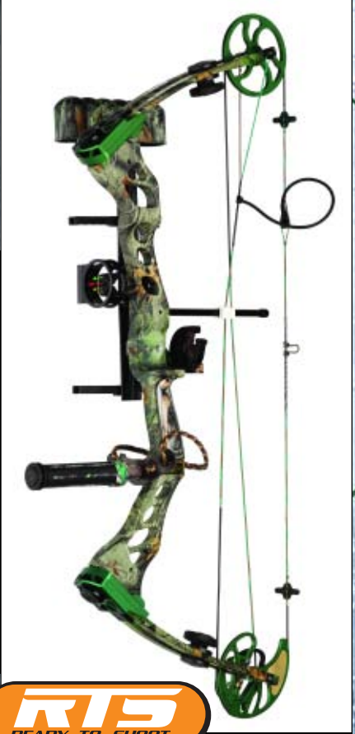 My bow

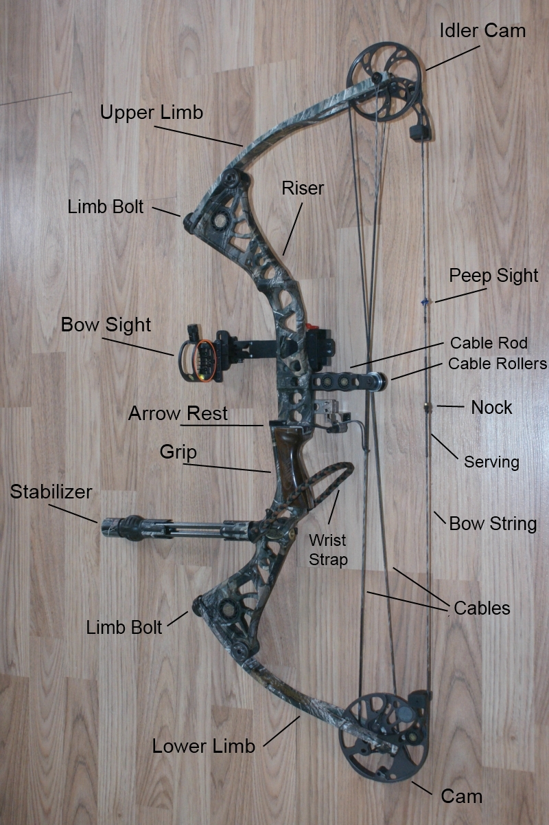

Parts of a Compound Bow
Riser: All limbs and accessories attach to this part which also contains the grip. Look for cracks or dents which could break or be causing vibration.
Upper Limb: The limbs flex allowing for energy to build up as the bow is drawn. The limbs should be screwed down as far as they go when starting to set up your bow. Inspect limbs for cracks which could cause the limbs to break when shooting. Periodically you will need to replace limbs as they can lose springiness over time.
Lower Limb: The lower limb functions like the upper but contains the cam. Also start setting up your bow with this limb screwed down as much as possible.
Limb Bolts: These bolts attach the limbs to the bow. Inspect them for rust, stripped sockets or threads, and cracks. To lower draw weight slightly unscrew each limb bolt exactly the same number of turns. To increase draw weight slightly tighten the bolts exactly the same number of turns.
Grip: The part of the compound bow you hold onto. Make sure it is properly attached and has no rough spots on it.
Idler Cam: The wheel on the upper limb is where the string passes over the top of the bow on its way back to the lower cam. The idler cam acts as a pulley when drawing the bow. Inspect the cam for scratches or dents which could lead to the part breaking. Also make sure the idler cam turns easily as the bow is drawn. This part is known as an idler wheel on some bows.
Cam: The cam is where the string and cable attach. As the bow is drawn the cam turns over allowing the archer to hold only a portion of the bow’s total draw weight. Inspect the cam for straightness, dents and scratches which could cut the string or cables. Make sure it is always free from dirt and has not seized if the bow has not been shot for a while.
Bow String: The string is where the arrow nocks (attaches) when shooting. As the string is drawn back tension is increased on the limbs allowing them to snap back into place when the string is released. Strings and cables stretch and break down over time so replace them a minimum of every two years for occasional shooters and even more frequently if you shoot often. Waxing strings and cables will help protect them and extend their life.
Cable: The cables attach to the upper limb and go down to the cam. As the bow is drawn they compress the limbs helping to increase energy. Inspect cables for fraying ends where they attach to the bow. Wax cables periodically to protect them and extend their life. Replace cables at the same time you replace your string.
Serving: The string that wraps around the bow string and cables is called the serving. This protects the bowstring and cables from wear as they come in contact with the cam, moving parts, or the arrow. Reserve the strings or cables as soon as the serving shows sign of wear or breakage.
Cable guard: The cable guard keeps the strings off to one side to allow the arrow clear passage from the bow. The cable guard is subjected to much vibration during shooting so inspect it frequently for cracks, and make sure it is smooth to allow the cable slide to move easily. Some manufacturers call this part of a compound bow a cable rod.
Cable Slide: Holds the cables together and allows them to slide along the cable guard during the draw and release. Inspect it for cracks and keep it dirt free. Some bows use a roller guard system instead; this is smoother during release and has less vibration.
Bow Sight: Sights mount on the front of the bow in the sight window of the riser. They allow for pin point accuracy when aiming. If your arrows are not shooting where you are aiming the sights usually need adjustment. Make small 1/32” changes and always follow your arrow. If the arrow hits high then move the sight up. If the arrow hits left then move the sight left. Make sure sights are firmly attached and replace the fibre optic thread every couple years as the colours fade and it becomes brittle with age.
Peep Sight: The peep is a rear sight inserted into the bow string. It allows the archer to line up with the front sights. Make sure it is always round and tightly served in place. Your archery pro shop will help you make sure it is in the right place when you get your bow.
Arrow Rest: The arrow rest holds your arrow as the bow is drawn. There are several different kinds but the drop away and whisker biscuit are the most popular. The drop away supports the arrow until release when it drops out of the way of the arrow. A whisker biscuit allows the arrow to pass through it which can affect the flight of the arrow. Make sure the arrow rest, bow sight, peep sight, and string are all aligned. This is called the center shot. If any part is out of alignment then likely there will be problems with arrow flight or accuracy.
Stabilizer: Stabilizers are rods of varying length that absorb vibration during release and counter balance the weight of the bow when it is drawn. Good stabilizers are at least 12” long for hunting and can be over 28” for indoor target shooting. Screw the stabilizer in tightly and inspect the threads each time it is attached to make sure they have not stripped.
Stabilizer Mount: This is where the stabilizer attaches. Make sure it is clear of dirt and that accessories are screwed in properly to prevent the threads from stripping.
Wrist strap: The wrist strap goes over the archers hand to prevent the bow from falling should the archer inadvertently let go.
String Nock or String Loop: The arrow attaches to the string here. Check the placement of the nock or loop often to make sure it hasn’t moved. Small changes in the position of either the nock or loop will cause the arrows to not shoot where you want them to.

Some measurements you should know.
1. Brace Height - The brace height is the distance from the "V" of the bow grip to the string in a resting position. Brace Heights can vary from 6" up to 9". The shorter the brace height the less forgiviging a bow will be and the longer the brace height the more forgiving a bow will be. The longer a brace height results in a shorter distance to pull in the draw cycle making it a little easier to draw but usually has less speed. The shorter brace height generally means faster speeds but a harder draw cycle. In my opinion a 7" brace height is optimal for hunting and backyard fun.
2. Draw Weight - As stated the draw length on most bows can be adjusted down 10 lbs. In the diagram you will see the arrows pointing to the limb bolts. This is where the draw length is adjusted. Most manufacturers recommend no more than four complete turns on each bolt (see manufacturers specs for your bow). Typically one complete turn will reduce the draw weight 2.5 lbs. When loosening the limb bolts to reduce the weight be sure to make sure you keep them even. If you turn 2-1/2 on the top then make sure you turn 2-1/2 on the bottom. If you forget or are not sure where you ended then tighten bolt limb bolts back down and start over.
3. Draw Length - The draw length is adjusted on the cam or cams of the bow. The bow featured on this page is a single cam bow and is very simple to adjust the draw length. The adjustments are made on the bottom cam (see picture). There is usually a set screw and a slide to adjust the length with numbers for letter corresponding to the desired draw length (see manufacturers recommendations). If you have a twin or double cam bow then adjustments will need to be made on the top and bottom cam.

Do not Dry Fire your Bow.
When you dry fire a bow, all the energy that is normally transferred from the bow to the arrow......stays with the bow. A bow is a big spring that has to be decompressed under load. The arrow acts as the load. Bows are not engineered to absorb the stress of a dry fire (some fare better than others). You can crack limbs, deform your cams, bend your axles, break your string or cables...................and injure yourself or someone else that happens to be in the vicinity. Shooting an arrow that is too light for your bow is also dangerous as that mimics a dry fire to some extent (that is why it is recommended that your arrow weighs a min of 5 grs per lb of draw weight.). I've got a nice scar on my wrist.......the result of a dry fire........both cams on the bow had to be replaced because they were deformed.

Safety rules
The compound Bow is a deadly weapon. Able to propel a graphite rod at over 300 feet per second, it has enough force to bring down an elk or a bear. If you follow a few simple safety guidelines,it won't bring down one of your friends.
When holding the bow, be sure never to point it at anything but the target. When carrying it, hold it loosely at your side, and never with an arrow nocked.
Don't draw the bow until you are facing the target and ready to shoot. This will prevent an accidental misfire if someone bumps into your arm before you are ready.
Be sure that your target is a special "archery-type" target. No paper bull's eyes on soda bottles, no cardboard boxes. The speed of the arrow requires a multi-density foam target designed especially to absorb the energy of the arrow. If you shoot anything else, your arrow will go straight through.
Even with the correct target, be sure of what's behind it. If you put your target in front of a brick wall and miss, you not only are looking at a broken arrow, but the risk of eye injury from shattering graphite.
Just try to use common sense when using the bow. Over time you will get better acquainted with its nuances and more comfortable handling it, but it is always good practice to treat it with respect.

Archery rules
What are the safety precautions for archery?
The primary safety precautions involve both supervision and teaching.
» The most obvious rule is: do not aim a bow at a person, living thing or breakable object.
» A bow must not be loaded with an arrow unless standing on the shooting line and the signal to start shooting has been given. This is often called out as “All clear” by the supervising person. This means that it’s OK to go ahead and load the arrow and then launch it.
» When each participant has finished shooting their arrows, they should stand back from the shooting line so the supervisor can clearly see that they have finished.
» Only when everyone has finished shooting should the signal to move forward to collect the arrows be given. This is often called out as “All clear” by the supervising person. This means that it’s OK to go ahead for everyone to step up to the target and retrieve arrows.
» If an arrow or part of equipment is dropped in front of the shooting line while shooting is in progress, it can only be picked up after shooting has stopped.
» Walk forward to collect the arrows, never run.
( Keep a eye on the ground for any arrows that may have dropped short of the target and lodged in the ground. Always withdraw the arrows in the opposite direction that they entered, so as not to bend or break the arrow.)
» Always walk up to the side of the target butt, so as to not to accidentally walk into the rear of the arrows lodged in the target.
» One person at a time should withdraw their arrows from the target.
» When withdrawing arrows from the target, make sure no one is standing in front of the target or in the way of the withdrawn arrows. Withdrawing the arrows may require some force and the arrows may come out suddenly from the target butt and the rear end of the arrow could hit someone standing in front of the target.
» Everyone shooting should help to find any arrows that may have missed the target.
» When carrying arrows, always hold them to the side POINTING DOWN or carry in a quiver and never run.
» Everyone must return to the shooting line and the range checked to make sure no one is behind the target butts or in the safety zone before the signal to commence shooting is given.
» If any person or animal enters the safety zone while shooting is in progress, the emergency signal must be given and all shooting must stop IMMEDIATELY.
Even if a bow is held at full draw and the signal is given, the arrow must not be released. The bow should be pointed at the ground and the bowstring let slowly forward. The arrow should be removed from the bow until the range is clear.
» Any person failing to abide by the safety rules is endangering themselves or others and should be required to leave the archery range.
» Allow at least 165 ( 50 meters ) behind the target butts as a safety zone for misses or arrows that may deflect off the top of the target butts. When using the stronger draw weight bows (+20 pounds = + 9 kg.), allow 250 feet (75 meters) for safety. The more clear space behind the target, the better.

